# IMRAN AHMED KHAN NIAZI

FORMER CRICKETER & EX PRIME MINISTER OF PAKISTAN

## Born on October 5, 1952, Imran Khan is a politician and former cricket player from Pakistan. From August 2018 until April 2022, he held the

position of 22nd prime minister. The political party Pakistan Tehreek-eInsaf (PTI) was founded by him, and he served as its chairman from 1996 to 2023. He led the Pakistani cricket team as captain during the 1980s and the first part of the 1990s. Khan is an Oxford graduate of Keble College.

He played his first Test match for his country, England, in 1971. Khan participated in the competition till 1992, led the team sporadically from

1982 to 1992, and led Pakistan to their lone World Cup victory in 1992.

|  |  |
| --- | --- |
| **SCHOOL** | Cathedral School,Lahore Worcester,England |
| **COLLEGE** | Aitchison College,Lahore |
| **UNIVERSITY** | Keble College Oxford |
| **SUBJECT** | Philosophy,Politics & Economics |

## Later, Khan—who is regarded as one of cricket's best all-round players— was admitted to the ICC Cricket Hall of Fame. Khan, who founded the Pakistan Tehreek-e-Insaf (PTI) in 1996, was elected to the National Assembly in the general election of 2002 and represented Mianwali as an opposition member until 2007. After abstaining from the 2008 general election, PTI emerged as the second-largest party in the popular vote at the 2013 election. PTI, standing on a populist platform in the 2018 general election, emerged as the biggest

## **EDUCATION**

## PERSONAL LIFE

Khan had numerous relationships during his bachelor life. He was then known as a hedonistic bachelor and a playboy who was active on the London nightclub circuit. Many girlfriends are unknown and were called "mysterious blondes" by British newspaper The Times. Some of the women he has been associated with include Zeenat Aman, Emma Sergeant, Susie Murray-Philipson, Sita White, Sarah Crawley, Stephanie Beacham, Goldie Hawn, Kristiane Backer, Susannah Constantine, Marie Helvin, Caroline Kellett, Liza Campbell, Anastasia Cooke, Hannah Mary Rothschild, and Lulu Blacker.

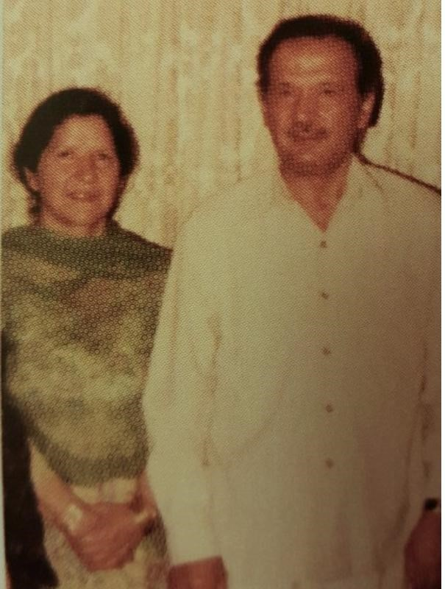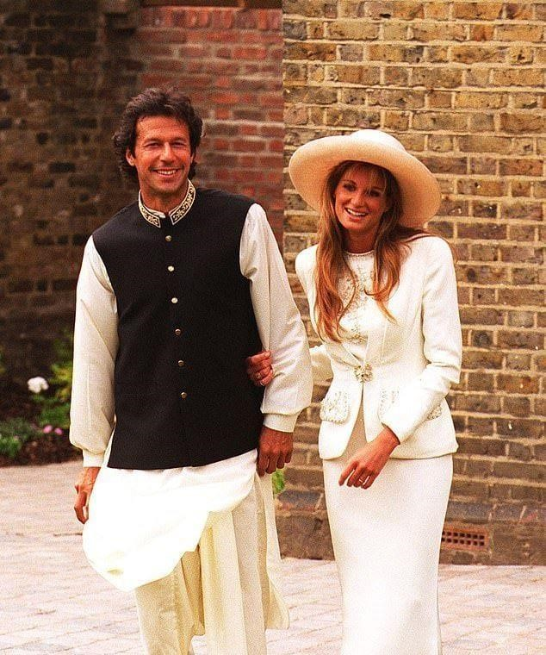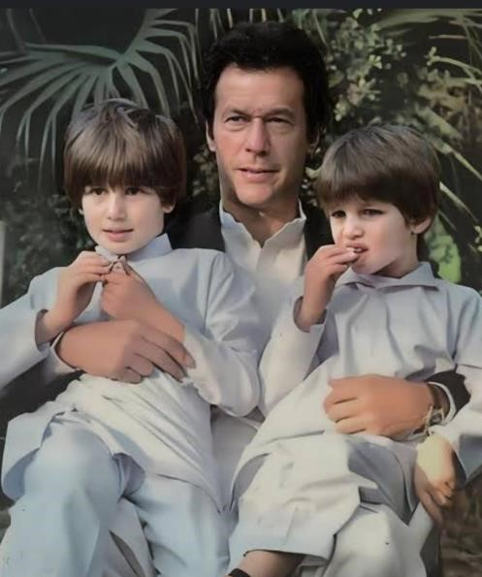

### PARENTS OF IMRAN KHAN IMRAN KHAN WITH HIS EX- IMRAN KHAN WITH HIS SON

WIFE,JAMIMA GOLDSMITH QASIM KHAN & SULEMAN KHAN

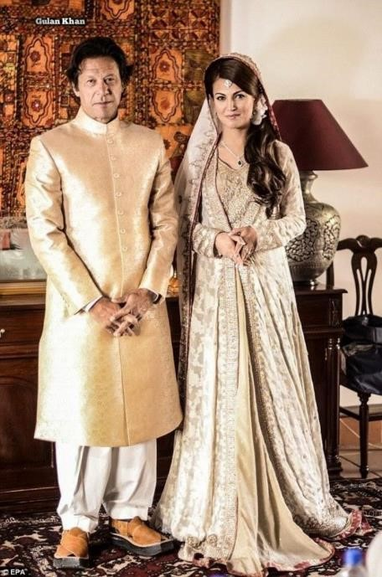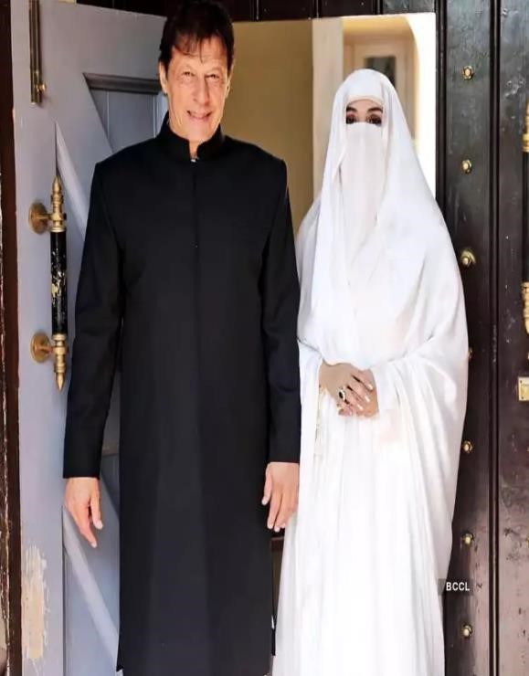

Imran khan and his ex-wife Imran khan & jamaima sons Imran khan and his wifi bushra bibi

reham Qasimand suleman

His first girlfriend, Emma Sergeant, an artist and the daughter of British investor Sir Patrick Sergeant, introduced him to socialites.They first met in 1982 and subsequently visited Pakistan.She accompanied him on various Pakistani cricket team tours including in Peshawar and Australian tour.After long separations, his relationship with Sergeant was broken in 1986. He then had a short relationship with Susie Murray-Philipson whom he invited to Pakistan and had dinner with in 1982. She also made various artistic portraits of Khan during their relationship.

In a book published in 2009, Christopher Sandford claimed that Khan and former Pakistani Prime

Minister Benazir Bhutto had a close relationship when both were students in Oxford.He wrote that Bhutto at the age of 21 first became close to Khan in 1975. They remained in a relationship for about two months.His mother also tried to have an arranged marriage between them.He further claimed that they had a "romantic relationship", which was refuted by Khan who said they were only friends.

Khan allegedly has a daughter, Tyrian Jade, with his ex-girlfriend Sita White, daughter of the British industrialist Gordon White. Born in June 1992, Tyrian became a subject of dispute as Khan denied paternity and willed for a paternity test in Pakistan, stating he would accept the decision of the Pakistani courts. Legal actions in 1997 led to a California court declaring Khan as the father without a DNA test. After Sita White's death in 2004, Jemima, Khan's wife at the time and Sita's friend, was designated as Tyrian's legal guardian by Sita in her will. Khan stated that Tyrian would be welcome to join their family in London, leaving the decision entirely up to her, given her established relationship with his and Jemima's sons.

Khan's former wife, Reham Khan, alleged in her book that he had told her that he had four other children out of wedlock in addition to Tyrian White. Allegedly, some of his children had Indian mothers and the eldest was aged 34 in 2018. Reham subsequently conceded that she did not know the identities of Khan's children or the veracity of his statements and that "you can never make out whether he tells the truth."Reham's book was published on 12 July 2018, 13 days before the 2018 Pakistani general election, leading to claims that its publication was intended to damage Imran Khan's electoral prospects.

On 16 May 1995, Khan married Jemima Goldsmith, in a two-minute ceremony conducted in Urdu in Paris. A month later, on 21 June, they were married again in a civil ceremony at the Richmond registry office in England. Jemima converted to Islam upon marriage. The couple have two sons, Sulaiman Isa and Kasim. On 22 June 2004, it was announced that the couple had divorced, ending the nine-year marriage because it was "difficult for Jemima to adapt to life in Pakistan."

In January 2015, it was announced that Khan had married British-Pakistani journalist Reham Khan in a private Nikah ceremony at his residence in Islamabad. Reham Khan later states in her autobiography that they in fact got married in October 2014 but the announcement only came in January the year after. On 22 October 2015, they announced their intention to file for divorce.

In mid-2016, late 2017 and early 2018, reports emerged that Khan had married his spiritual mentor (murshid), Bushra Bibi. Khan himself, alongside PTI aides,as well as members of the Manika family, denied the rumour. Khan termed the media "unethical" for spreading the rumour, and PTI filed a complaint against the news channels that had aired it.On 7 January 2018, the PTI central secretariat issued a statement that said Khan had proposed to Manika, but she had not yet accepted his proposal. On 18 February 2018, PTI confirmed Khan has married Manika.According to Khan, his life has been influenced by Sufism for three decades, and this is what drew him closer to his wife. The Mufti who conducted the marriage later testified to a court that Khan's nikah had been conducted twice. The first nikah was conducted on 1 January 2018, while his to-be wife was still in her Iddat, as Khan believed he would become prime minister if he married her on that date.

Khan resided in his sprawling farmhouse at Bani Gala. As of 2018, he owned five pet dogs, who resided in his estate

# HISTORY OF IMRAN KHAN

Cricket Career (1971-1992):

Imran Khan made his Pakistani cricket team debut in 1971, and his skill as a fast bowler and all-rounder soon brought him attention.

* He spent more than 20 years as an international cricket player for Pakistan, rising to become one of the sport's most renowned players worldwide.
* Khan's greatest accomplishment was leading the Pakistani cricket team to victory in the Australia-hosted ICC Cricket World Cup in 1992. One of the most treasured victories in Pakistani sports history is still this one. - Throughout his cricket career, Khan was renowned for his charisma, leadership abilities, and commitment to the game.

Political Activism and Philanthropy:

* Following his 1992 retirement from cricket, Imran Khan turned his attention to political involvement and philanthropy.
* After his mother passed away from cancer, he established the Shaukat Khanum Memorial Cancer Hospital & Research Centre in Lahore. The hospital is one of the biggest charitable cancer hospitals in the world, offering free care to impoverished cancer patients.
* In Mianwali, Pakistan, Khan also founded Namal University with the intention of giving rural youngsters access to a top-notch education.

Political Career and Struggles:

*

* Khan faced numerous challenges and setbacks in his political career, including electoral defeats and accusations of being a political outsider and opportunist. - He participated in several general elections, gradually increasing PTI's influence and electoral presence.

Entry into Politics (1996)

* Imran Khan first became involved in Pakistani politics in 1996 when he established the Pakistan Movement for Justice, or Pakistan Tehreek-e-Insaf (PTI).
* Khan persisted in pushing for social justice, anti-corruption initiatives, and political reform despite the PTI's early difficulties in gaining foothold in Pakistani politics.

Rise to Power (2018):

* Imran Khan's persistence paid off in July 2018, as the PTI emerged victorious in the national elections. With the party's majority of seats in the National Assembly, Khan was able to take office as Pakistan's prime minister. - With Khan's election, Pakistani politics underwent a dramatic change as the nation's top position went to a former athlete and outsider.

Prime Ministership and Policy Initiatives:

Imran Khan has implemented an ambitious plan as prime minister that is centered on combating corruption, advancing economic growth, and enhancing social welfare. His administration has put into effect a number of policy initiatives, such as programs to reduce poverty, anti-corruption measures, and attempts to draw in foreign investment.

Challenges and Criticisms:

* Khan has faced difficulties during his time serving as prime minister. His handling of foreign policy choices, apparent dictatorial tendencies, and economic concerns have all drawn criticism. In addition, opposition parties and other interest groups have opposed Khan's government.

All things considered, Imran Khan's life and career show an incredible transformation from a cricketing superstar to a revolutionary political figure in Pakistan. His influence goes beyond sports; he has left a long legacy in public service and philanthropy.

# IMRAN KHAN: CRICKET CAREER

Khan made his first debut at the age of 16 in Lahore. By the start of the 1970s, he was playing for his home teams of Lahore A (1969–1970), Lahore B (1969–1970), Lahore Greens (1970–1971), and eventually Lahore (1970–1971).Khan was part of the University of Oxford's Blues Cricket team during the 1973–1975 seasons. Khan played English county cricket from 1971 to 1976 for Worcestershire. During this decade, other teams represented by Khan included Dawood Industries (1975–1976) and Pakistan International Airlines (1975–1976, 1980–1981). From 1983 to 1988, he played for Sussex.

khan made his Test cricket debut against England in June 1971 at Edgbaston.Three years later,**In August 1974, he debuted in the One Day International (ODI) match**, once again playing against England at Trent Bridge for the Prudential Trophy.After graduating from Oxford and finishing his tenure at Worcestershire, he returned to Pakistan in 1976 and secured a permanent place on his native national team starting from the 1976–1977 season, during which they faced New Zealand and Australia. Following the Australian series, he toured the West Indies, where he met Tony Greig, who signed him up for Kerry Packer's World Series Cricket. His credentials as one of the fastest bowlers in the world started to become established when he finished third at 139.7 km/h in a fast bowling contest at Perth in 1978, behind Jeff Thomson and Michael Holding but ahead of Dennis Lillee, Garth Le Roux, and Andy Roberts.During the late 1970s, Khan was one of the pioneers of the reverse swing bowling technique. He imparted this trick to the bowling duo of Wasim Akram and Waqar Younis, who mastered and popularised this art in later years. As a bowler, Khan initially bowled with a relatively chest-on action, at medium-pace;[80] however, he worked hard to remodel his action to a more classical type, and to strengthen his body, to enable fast bowling. Khan attained his prime as a fast bowler in January 1980 till 1988 when he became out and out fast bowler. **During this span Imran picked 236 test wickets at 17.77 apiece with 18 five-wicket hauls and 5 10 wicket hauls.** His bowling average and strike rate were better than Richard Hadlee (19.03), Malcolm Marshall (20.20), Dennis Lillee (24.07), Joel Garner (20.62), and Michael Holding. In January 1983, playing against India, he attained a Test bowling rating of 922 points. Although calculated retrospectively (International Cricket Council (ICC) player ratings did not exist at the time), Khan's form and performance during this period ranks third in the ICC's All-Time Test Bowling Rankings.

**Khan achieved the all-rounder's triple (securing 3000 runs and 300 wickets) in 75 Tests,** the second-fastest record behind Ian Botham's 72. He also has the second-highest all-time batting average of 61.86 for a Test batsman playing at position 6 in the batting order. He played his last Test match for Pakistan in January 1992, against Sri Lanka at Faisalabad. Khan retired permanently from cricket six months after his last ODI, the historic 1992 Cricket World Cup Final against England in Melbourne, Australia. He ended his career with 88 Test matches, 126 innings and scored 3807 runs at an average of 37.69, including six centuries and 18 fifties. His highest score was 136. As a bowler, he took 362 wickets in Test cricket, which made him the first Pakistani and world's fourth bowler to do so. In ODIs, he played 175 matches and scored 3709 runs at an average of

33.41. His highest score was 102 not out. His best ODI bowling was 6 wickets for 14 runs, a record for the best bowling figures by any bowler in an ODI innings in a losing cause.

# POST-FROM CRICKET RETIREMENT

After retiring, Khan remarked that there was ball tampering during his early cricketing days when playing domestic cricket. Khan had said that, during matches, he "occasionally scratched the side of the ball and lifted the seam". Khan defended his actions in the same

interview, arguing his conduct was commonplace at the time, even that spin bowlers would lift the seam (i.e. mildly ball tamper); further Khan argued that as he did not lift the seam of the ball above the normal level he was not violating the rules and spirit of the game within the rules defined whilst he was a player. Further, Khan argued that umpires in his 21 years of cricket had not complained about his conduct; Khan remarked that "The sole judge of fair and unfair play on the cricket field is the umpire". He had also added, "Only once did I use an object. When Sussex was playing Hampshire in 1981 the ball was not deviating at

all. I got the 12th man to bring out a bottle top and it started to move around a lot. As a captain, Khan played 48 Test

matches, of which 14 were won by Pakistan, 8 lost and the remaining 26 were drawn.

In 1996, Khan successfully defended himself in a libel action brought forth by former English captain and all-rounder Ian Botham and batsman Allan Lamb over comments they alleged were made by Khan in two articles about the above-mentioned ball-tampering and another article published in an Indian magazine, India Today. They claimed that, in the latter publication, Khan had called the two cricketers "racist, ill-educated and lacking in class." Khan protested that he had been misquoted, saying that he was defending himself after having admitted that he tampered with a ball in a county match 18 years ago. Khan won the libel case, which the judge labelled a "complete exercise in futility", with a 10–2 majority decision by the jury. Also, Khan had served as a domestic league coach.

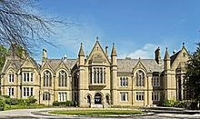 Since retiring, Khan has written opinion pieces on cricket for various British and Asian newspapers, especially regarding the Pakistani national team. His contributions have been published in the Indian magazine Outlook,The Guardian,The Independent, and The Daily Telegraph. Khan also sometimes appears as a cricket commentator on Asian and British sports networks, including BBC Urdu,as well as the Star TV network.In 2004, when the Indian cricket team toured Pakistan after 14 years, he was a commentator on TEN Sports' special live show, Straight Drive,while he was also a Sify columnist for the 2005 India-Pakistan Test series. He has provided analysis for every cricket World Cup since 1992, which includes providing match summaries for the BBC during the 1999 Cricket World Cup. He holds as a captain the world record for taking most wickets, best bowling strike rate and best bowling average in Test,and best bowling figures (8 wickets for 60 runs) in a Test innings,and also most five-wicket hauls (6) in a Test innings in wins.

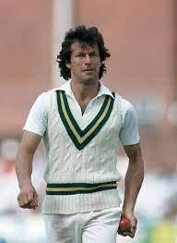

On 23 November 2005, Khan was appointed as the chancellor of

Khan served as the chancellor of the University of Bradford

University of Bradford, succeeding Betty Lockwood. On 26 February between November 2005 and November 2014..

2014, University of Bradford Union floated a motion to remove Khan from the post over Khan's absence from every graduation ceremony since 2010. Khan announced that he would step down on 30 November 2014, citing his "increasing political commitments".Brian Cantor, the

# IMRAN KHAN: POLITICAL CAREER

**Imran Khan's political journey has been characterized by his commitment to anticorruption, social justice, and a strong stance on governance issues. Here's a detailed look at his political career:**

**Formation of Pakistan Tehreek-e-Insaf (PTI):**

Imran Khan founded PTI in 1996 with the aim of creating a political platform focused on anti-corruption, social justice, and accountability. The party's initial years were marked by struggles to gain mainstream support, but it gradually emerged as a significant player in Pakistani politics.

**Advocacy and Opposition (1996-2013):**

In the years leading up to the 2013 general elections, Imran Khan and PTI focused on grassroots mobilization and advocacy for political reforms. Khan was a vocal critic of corruption within the Pakistani political establishment and called for accountability and transparency in governance.

|  |  |
| --- | --- |
|  | university's vice-chancellor, said Khan had been "a wonderful role model for our students". |

**Electoral Breakthrough (2013):**

In the 2013 general elections, PTI experienced a significant electoral breakthrough emerging as the second-largest party in the National Assembly. While PTI formed a government in the Khyber Pakhtunkhwa province, Imran Khan's bid for the prime ministership was unsuccessful, and he became the leader of the opposition in the National Assembly.

**2014 Dharna (Sit-in) and Azadi March:**

In 2014, Imran Khan led a massive protest in Islamabad, known as the Azadi March, to demand electoral reforms and accountability for alleged rigging in the 2013 elections. The protest resulted in a prolonged sit-in and political turmoil but ultimately did not achieve its stated objectives.

**2018 General Elections and Prime Ministership:**

Imran Khan's political fortunes changed in the 2018 general elections when PTI emerged as the largest party in the National Assembly. Imran Khan was elected as the 22nd Prime Minister of Pakistan on August 18, 2018. His victory was seen as a significant shift in Pakistani politics, marking the first time a party other than the Pakistan Muslim League-Nawaz (PML-N) or Pakistan Peoples Party (PPP) formed the federal government.

**Challenges and Criticism:**

Imran Khan's tenure as Prime Minister has been marked by challenges, including economic difficulties, political opposition, and criticism of his leadership style. His government has faced scrutiny over its handling of economic issues, including inflation and fiscal management. Additionally, Khan has been criticized for his handling of human rights issues and relations with the military establishmen Throughout his political career, Imran Khan has maintained a populist appeal,presenting himself as a champion of the people against entrenched political elites. Despite facing numerous challenges and criticisms, he remains a prominent and influential figure in Pakistani politics.

## ACHIEVEMENT OF IMRAN KHAN

Hilal-e-Imtiaz

(Crescent of Excellence)

-One of Pakistan's highest civilian honors,given for exceptional contributions to the country.Another distinguished civilian award in Pakistan,the Pride of Performance Award honors people who have significantly advanced their fields.

Sportsman of the Year `

-Throughout his cricket career, Imran Khan won several times for his exceptional on-field efforts.

Pride of Performance Award `

-An additional distinguished civilian honor in Pakistan given to people who have significantly advanced their fields.

ICC Cricket Hall of Fame `

-Imran Khan was admitted into the ICC Cricket Hall of Fame in 2010 in honor of his accomplishments and contributions to the game of cricket.

Lifetime Achievement Award `

-In honor of his enduring commitment to cricket and his ensuing social and political accomplishments. Jinnah Award `

-In honor of his enduring commitment to cricket and his ensuing social and political accomplishments.

|  |  |
| --- | --- |
| PAKISTAN won the 1992 ODI Cricket World Cup UNDER THE CAPTAINCY OF IMRAN KHAN. After retirement, Khan started philanthropy work. In 1996, Khan founded the Pakistan Tehreek-e-Insaf  (PTI) party. In 1983, he was recognized by Wisden Cricketers' Almanack as the Wisden Cricketer of the Year. |  |
|  | The final of the 1992 ICC Cricket World Cup was played at the Melbourne Cricket Ground,  Melbourne on 25 March 1992. The match was won by Pakistan, under the captaincy of Imran Khan, as they defeated England by 22 runs to lift their first ever World Cup trophy. |
| The inspiration to build the Hospital came after his mother, Mrs. Shaukat Khanum, succumbed to cancer in 1985. During his mother's illness, he witnessed up-close the plight of poor cancer patients in the hospitals of Pakistan and realised the need for a specialized cancer centre in his country. |  |
|  | Imran Khan made the momentous decision to build  an academic institution on the banks of the eponymous lake with a vision to empower  Pakistan's youth. Despite early obstacles, Namal College was established in 2008 with the support of the local community and generous donors. |
| Imran Khan is a Pakistani politician and former cricketer who served as the 22nd prime minister of Pakistan from August 2018 until April 2022. He is the founder and former chairman of the political party Pakistan Tehreek-e-Insaf from 1996 to 2023. |  |